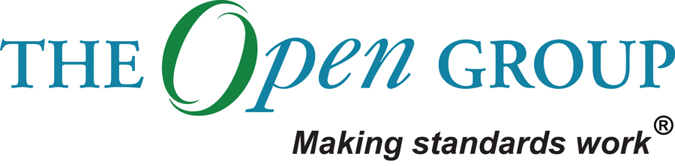
Tailored Architecture Framework
Project XXXX
Client YYYY
<<Note: This document provides a generic template. It may require tailoring to suit a specific client and project situation.>>
Table of Contents
1 Purpose of this Document 3
2 Tailored Architecture Method 4
3 Tailored Architecture Content 5
4 Configured and Deployed Tools 6
5 Interfaces with Governance Models and Frameworks 7

Document Information
Project Name: | Project XXX
Prepared By: |  | Document Version No: | 0.1
Title: | Tailored Architecture Framework | Document Version Date:
Reviewed By: |  | Review Date:
Distribution List
From | Date | Phone/Fax/Email

To | Action* | Due Date | Phone/Fax/Email
* Action Types: Approve, Review, Inform, File, Action Required, Attend Meeting, Other (please specify)
Document Version History
Version  Number | Version  Date | Revised By | Description | Filename

Purpose of this Document
This document describes the Tailored Architecture Framework.
TOGAF provides an industry standard framework for architecture that may be used in a wide variety of organizations. However, before TOGAF can be effectively used within an architecture project, tailoring at two levels is necessary.
Firstly, it is necessary to tailor the TOGAF model for integration into the enterprise. This tailoring will include integration with project and process management frameworks, customization of terminology, development of presentational styles, selection, configuration, and deployment of architecture tools, etc. The formality and detail of any frameworks adopted should also align with other contextual factors for the enterprise, such as culture, stakeholders, commercial models for enterprise architecture, and the existing level of architecture capability.
Once the framework has been tailored to the enterprise, further tailoring is necessary in order to tailor the framework for the specific architecture project. Tailoring at this level will select appropriate deliverables and artifacts to meet project and stakeholder needs.

Tailored Architecture Method

Architecture Method

Tailored Architecture Content
<<Deliverables and artifacts.>>

Architecture Deliverables

Architecture Artifacts

Configured and Deployed Tools

Tools

Interfaces with Governance Models and Frameworks

Enterprise Architecture Management Framework

Capability Management Framework

Portfolio Management Framework

Project Management Framework

Operations Management Framework

